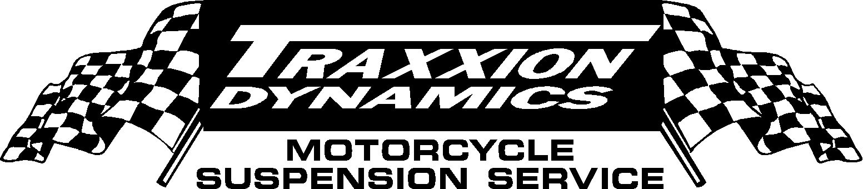

261 Rope Mill Parkway, #3
Woodstock, Georgia 30188

Telephone: (770) 592-3823 Fax: (770) 517-9332

GL1800 “FORK SPRING ONLY” KIT INSTALLATION

We are pleased you that you have purchased our product. Your new fork springs are made of the finest materials available, and put through a rigorous manufacturing process to ensure optimum performance for the life of your motorcycle. Changing fork springs is not always as simple as it sounds. If you have any questions about the installation, don't hesitate to call. If properly installed, our product will work exceptionally. If you are dissatisfied for any reason, let us know. We want you to be happy with our product.

READ THESE INSTRUCTIONS ENTIRELY BEFORE YOU GO ANY FURTHER!!!

These instructions assume you are willing to purchase proper tools, and do a professional quality job.
These instructions will only show you how to correctly do this job, without “shortcuts”, and without home-rigged devices and improper tools.

WARNING: Always work in a well-lit area, use the proper tools, and wear safety glasses. In general, springs can be dangerous, and you should work with great caution and care.

NOTE: Before you remove the forks from the bike, loosen the upper triple clamp bolts, and then loosen the fork caps. Do not remove the caps, just loosen them. If one is stuck, place a socket on top of the fork, and whack it several times with a ball peen hammer. This should loosen the threads. Then remove the forks from the bike, per the Honda Service Manual.

It is helpful to have a 5” bench vise mounted near the edge of a workbench, but not absolutely necessary. If you have a vise clamp the fork in a bench vise, using a pair of aluminum jaws (See Figure 1A). Many hardware stores have aluminum vise jaws with a variety of clamping grooves that make this job easier (available from Traxxion Dynamics for $15). Do not grab the fork near the top ( you will pinch the cap and make it difficult to remove), nor in the area where the seal slides (See Figure 1B).

Remove the Left Fork Cap (anti-dive fork) slowly, as it can release with great force. Keep firm constant pressure on your ratchet or wrench, to prevent the fork cap from flying off and potentially injuring you or causing unnecessary damage.

There should be no danger from unscrewing the right fork cap (cartridge fork). Once you unscrew the fork cap from the fork tube, pull up on the cap to expose the jam nut. Hold cap and loosen the jam nut at the base of the fork cap with a 14mm wrench, while holding the top of the cap with a 17mm wrench. Then unthread the cap completely.

After the fork caps have been removed, extract the stock washers, spacers and springs.

It is HIGHLY recommended that you change your fork oil now. If you are not going to change you fork oil, then remove the stock fork spring as if you were unscrewing a bolt. This will keep as much oil as possible in the fork, and only slightly affect the level.

At a MINIMUM, you should check the oil level with a fork oil level gauge (available from Traxxion Dynamics, See Figure 2A). You MUST set the oil by level, not by pouring in a pre-measured volume, or your bike will not work properly, and you will be wasting your time and money.

Any Honda GL1800 with 20,000 miles or more should have the forks completely disassembled, cleaned and inspected following the instructions in the Honda Service Manual. We find over 80% of Honda GL1800s will have worn lower bushings, which are a contributing factor to the “Gold Wing Wobble”.

Fill each fork with ½ quart of oil, and pump the chrome tube up and down to bleed air from in between the tube and leg.

Oil recommendations:

Left leg, Anti-dive functioning: Use the thinnest oil you can find to help eliminate harshness.

Left leg, Anti-dive disabled: It doesn't matter, so you can use whatever you have in the right leg.

Right leg hot climates: 20 wt

Right leg normal climates: 20wt

Right leg cold climates 10wt depending on just how cold and how long it's cold!

Note that unfortunately, as you go up in viscosity, the fork will have more damping control, but will be less compliant over sharp bumps. This is because the double damped right cartridge can't handle sharp bumps.

Be sure the right fork is thoroughly bled using a fork bleed tool (available from Traxxion Dynamics $10-20, See Figure 3A). A well bled fork will have no “skips” in the stroke as you pull up on the cartridge rod (See Figure 3B).

Oil level is measured from the top of the fork tube with the spring out, and all parts of the fork collapsed as far as possible (See Figure 3C).

Traxxion Recommended Oil Level for the GL1800 is 125mm.

Insert Traxxion Springs into each tube.

Place factory washer on top of each spring,

Install spacers. Long spacer in left leg, short spacer in right leg.

Install Traxxion washer on top of spacers. Please note this washer is a little larger diameter then the tube and does not go down in the fork tube it pushes up against the fork cap. This is normal.

SEE DIAGRAM IF YOU DON’T UNDERSTAND!!!

Thread the left fork cap down into the tube. Be careful not to cross-thread the cap. Do not use any threadlocking agent. DO NOT OVERTIGHTEN THE FORK CAP!!! 6 ft/lbs of torque is all that is required (like a little tiny screw!!!).

Using the fork bleed tool, pull the cartridge rod up out of the oil in the right leg.

Thread the cap onto the rod, until it bottoms out. Spin jam nut up rod and tighten to fork cap. DO NOT OVERTIGHTEN THIS NUT!!! Firm pressure on the wrenches is all that is required.

Thread the right fork cap down into the tube. Be careful not to cross-thread the cap. Do not use any threadlocking agent. DO NOT OVERTIGHTEN THE FORK CAP!!! 6 ft/lbs of torque is all that is required (like a little tiny screw!!!).

Reassemble the bike per the Honda Service Manual. When installing the forks back on the bike raise the forks 10mm in the triple clamps. So from the top of the fork cap to the top of the triple clamp you should have 10mm.

Now, go have fun! We hope you enjoy your new suspension!

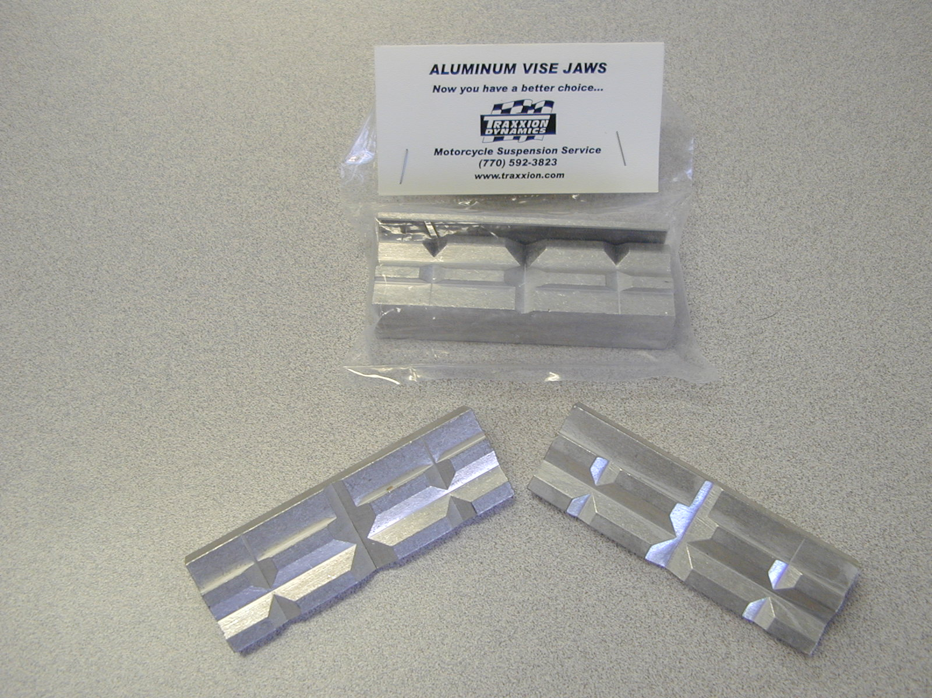  Figure 1A | 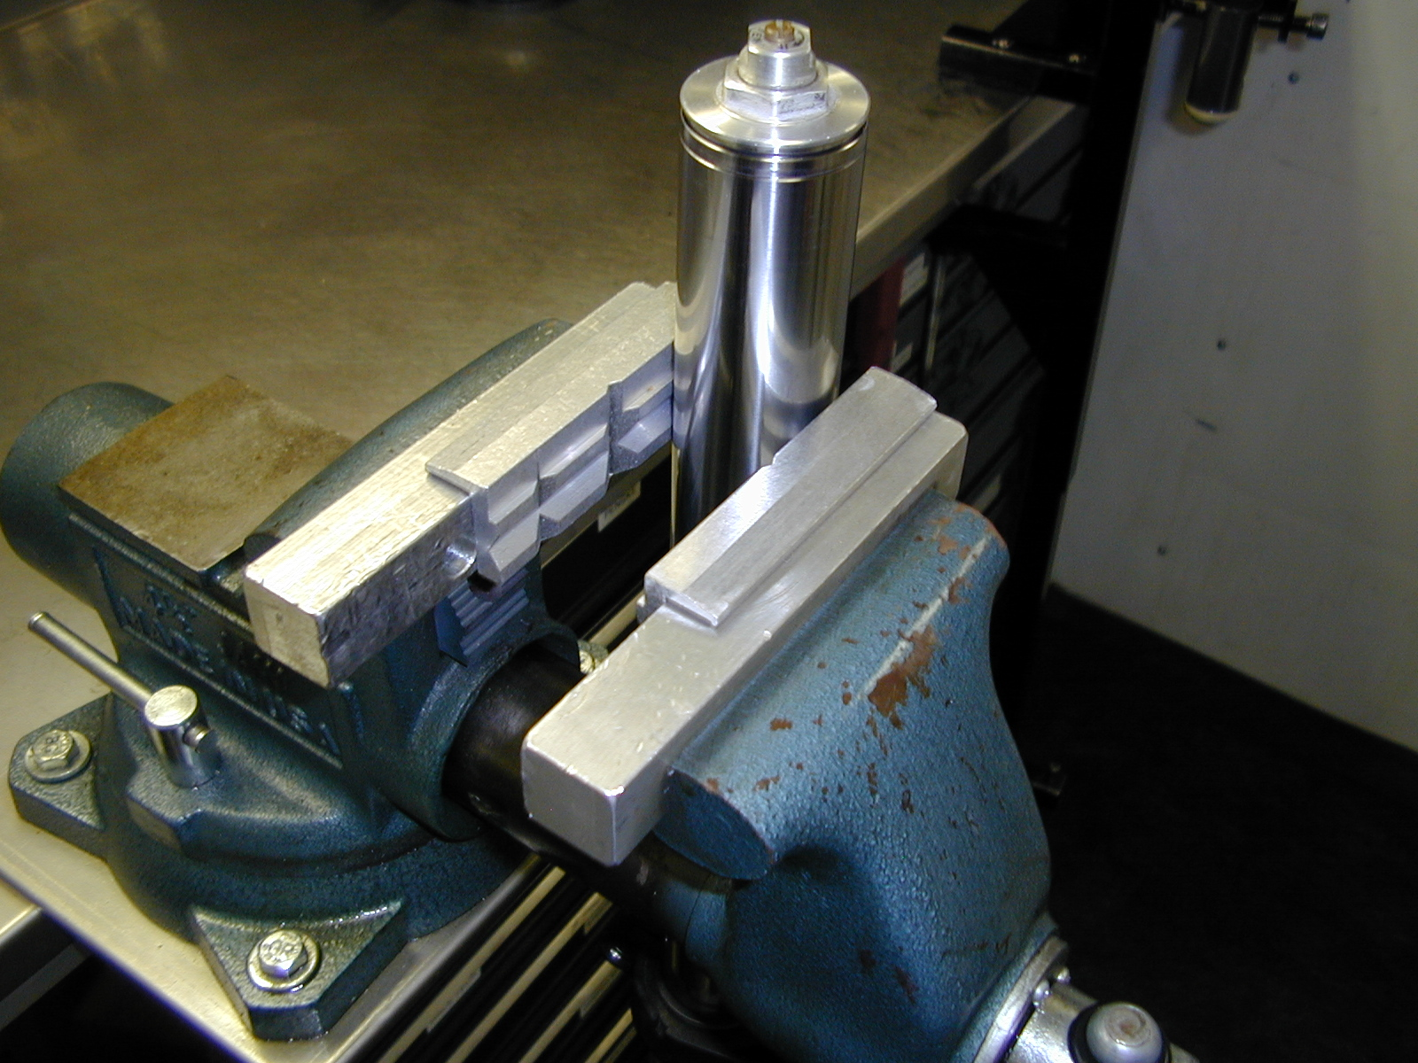  Figure 1B
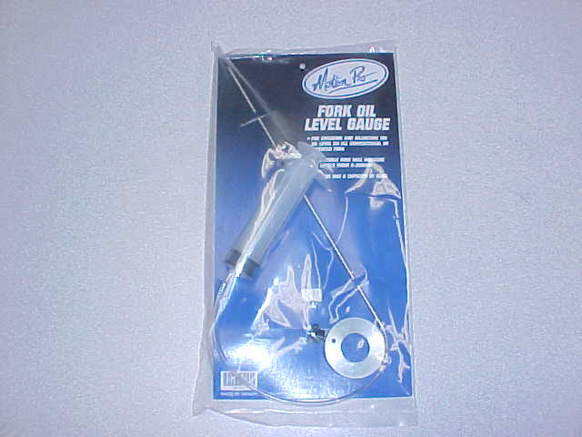

Figure 2A

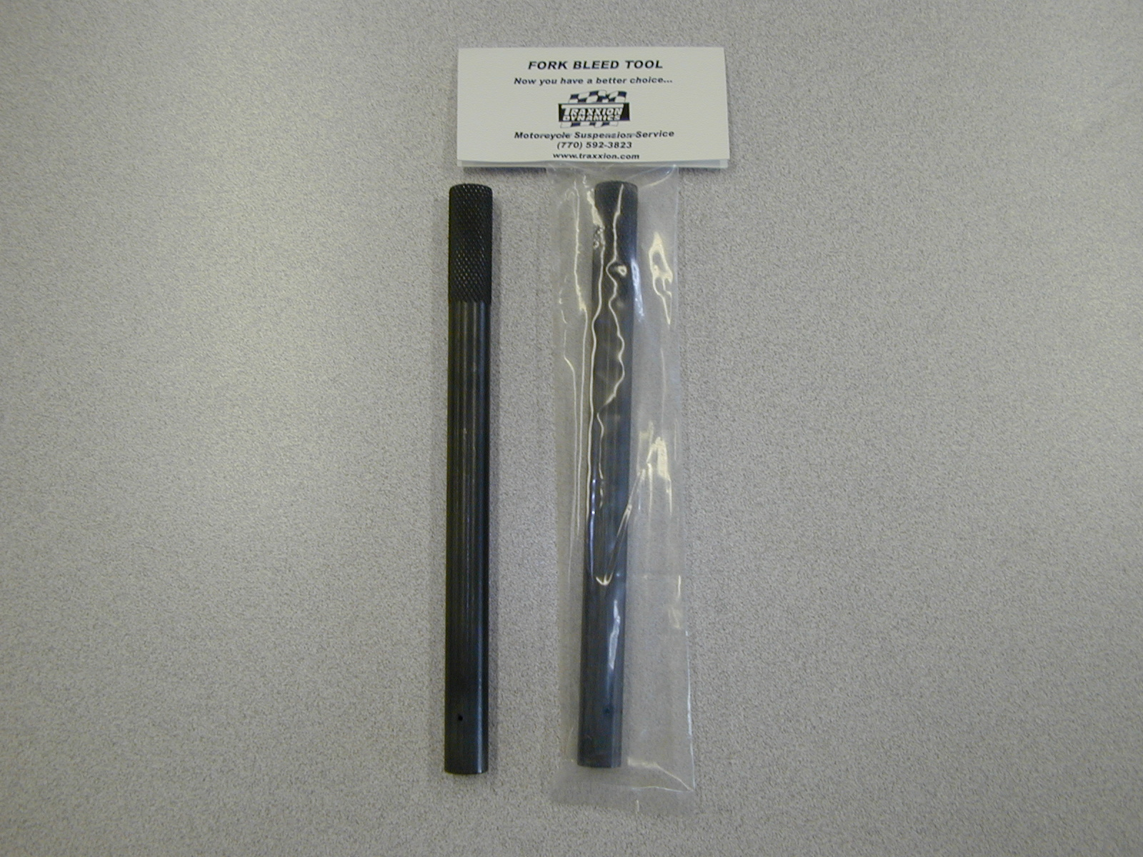  Figure 3A | 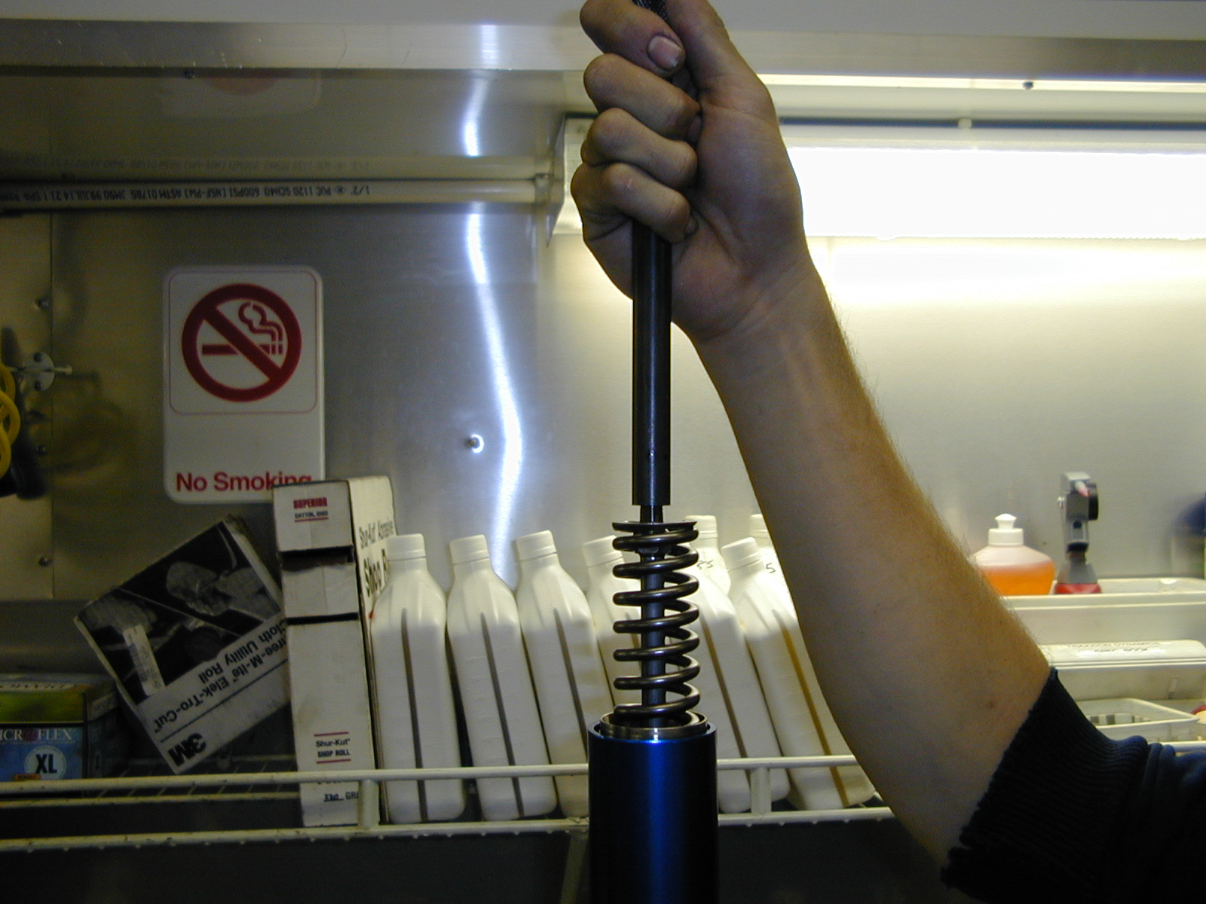  Figure 3B
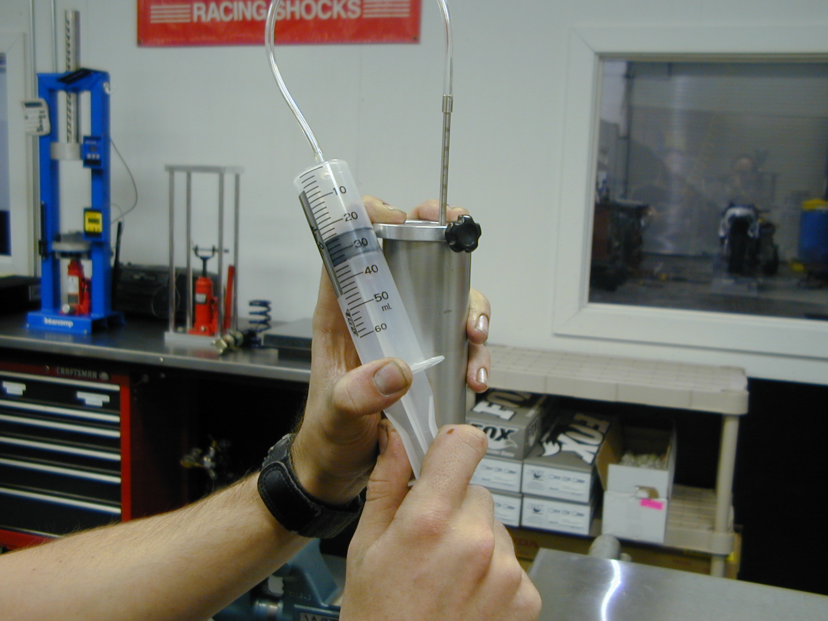

Figure 3C

